**Software Requirements Specification**

**for**

**Leaflings**

**Version 3.0 approved**

**Prepared by João Pedro Santos**

**Reviewed by:**

**Hugo Guimarães**

**Pedro Pinho**

**Sónia Oliveira**

**ESTG**

**Grupo 10**

**26-09-2024**

**Table of Contents**

1. Introduction 1

1.1 Purpose 1

1.2 System Proposal 1

1.3 Product Scope (New scope done) 3

1.4 References ( MISSING ) 4

1.5 Product Perspective 4

1.6 Operating Environment 4

1.7 Design and Implementation Constraints 5

1.8 Assumptions and Dependencies 5

2. External Interface Requirements 6

2.1 User Interfaces 6

2.1.1 User Interfaces – Mobile Version – First Screens (Login and Register) 6

2.1.2 User Interfaces – Mobile Version – Homepage 7

2.1.3 User Interfaces – Mobile Version – User Homepage 8

2.1.4 User Interfaces – Mobile Version – Edit Account Screens 9

2.1.5 User Interfaces – Web Browser – First Screens (Login and Register) 10

2.1.6 User Interfaces – Web Browser – Homepage 11

2.1.7 User Interfaces – Web Browser – User Homepage 12

3. Use Case Scenarios 14

3.1 User Management 14

3.2 Plant Database and Matchmaking 18

3.3 Administration 22

3.4 Other Functional Requirements 26

3.5 Product Backlog 28

4. Other Nonfunctional Requirements 31

4.1 Security Requirements 31

4.2 Software Quality Attributes 32

5. Diagrams 33

5.1 Package Diagram 33

5.2 Sequence Diagrams 34

*5.3* Class Diagram 41

*5.4* Architecture Diagram 42

6. Database Design and Normalization 43

6.1 ER Diagram 43

*6.2* Identify Entities and relationships 44

6.3 Assign keys to entities 46

6.4 Solve redundancies 46

6.5 Conceptual Model 47

6.6 Data Dictionary 48

6.7 Logical Model 51

7. Use Case 53

*7.1* User Management 53

7.2 Administration 54

7.3 Plant Matchmaking 55

**Figure Index**

Figure 1 - Revision History 6

Figure 2- Login/register screens Register Screen Login Screen 6

Figure 3- Homepage Screen 7

Figure 4- User Homepage Screens Check Plant Screen My Plant Diary 8

Figure 5 - Edit Account and Preferences Screen 9

Figure 6 - Browser LandingPage 10

Figure 7 - Register Screen 10

Figure 8 - Login Screen 10

Figure 9 - Homepage 11

Figure 10 - Card presentation 11

Figure 11 - profile homepage 12

Figure 12- check a user owned plant 12

Figure 13 - Change Preferences Page 13

Figure 14 - Package Diagram 33

Figure 15- Register Sequence Diagram 34

Figure 16 - Fill Profile Sequence Diagram 35

Figure 17 - Edit User Profile Sequence Diagram 36

Figure 18 - Get Matching Plant Sequence Diagram 37

Figure 19 - Add New Plant Sequence Diagram 38

Figure 20 - Remove Plant Sequence Diagram 39

Figure 21 - View User's Plants Sequence Diagram 40

Figure 22- Class Diagram 41

Figure 23 - Architecture Diagram 42

Figure 24 - First ER Diagram 43

Figure 25- conceptual model 47

Figure 26 - Data Dictionary 50

Figure 27 - Logical Diagram, foreign keys are represented with the letter U 52

Figure 28 - Use Case Register and authentication 53

Figure 29 - use case administration 54

Figure 30 - use case Plant Matchmaking 55

**Table Index**

Table 1- Register User Use Case 14

Table 2 - Func Requirement Login And Register 14

Table 3 - Use Case Scenario Login 15

Table 4- Func Requirement Login and Register 15

Table 5 - Use Case Scenario Create User Profile 16

Table 6 - Func Requirement Profile Creation 16

Table 7- Use Case Scenario Alter User Profile 17

Table 8 - Func Requirement Profile Alteration 17

Table 9- Use Case Scenario Access Plant Directory 18

Table 10 - Func Requirement Plant Directory Access 18

Table 11 - Func Requirement Plant Info Display 19

Table 12 - Func Requirement Plant Info Display 19

Table 13 - Func Requirement Searching And Filtering 20

Table 14 - Use Case Scenario Match Plants To Users 20

Table 15 - Func Requirement Plant Matchmaking 21

Table 16 - Use Case Scenario Adding Plants to Users Favorites 21

Table 17 - Func Requirement Add Plant To Garden 22

Table 18 - Use Case Scenario Remove User 22

Table 19 - Func Requirement Remove User 23

Table 20 - Use Case Scenario Access User Information 23

Table 21 - Func Requirement User Information Access 24

Table 22 - Use Case Scenario Plant Creation 24

Table 23 - Func Requirement Plant Creation 25

Table 24 - Use Case Scenario Edit Plant Information 25

Table 25 - Func Requirement Plant Edition 26

Table 26 – Func Requirement Reminder System 26

Table 27 - Func Requirement Streaks 27

Table 28 - Non Func Requirement Password Encryption 31

Table 29 - Non Func Requirement Token Authentication 31

Table 30 - Non Func Requirement Ease of Use 32

Table 31 - Identify Entities and Relationships 44

Table 32 - Multiplicity of relationships 45

**Revision History**

|  |  |  |  |
| --- | --- | --- | --- |
| **Name** | **Date** | **Reason For Changes** | **Version** |
| João Santos | 03/10/2024 | Corrections to | **1.1** |
| João Santos | 16/10/2024 | Adding Use Cases | **1.2** |
| João Santos | 17/10/2024 | Added Diagrams and Requirements | **2.0** |
| João Santos | 22/10/2024 | Introduce figure index, introduced table index, introduced new ER diagram, introduced conceptual drawing and normalization process, changed Scope, changed Class Diagram, changed use cases, introduced product backlog to the report. Added new class Diagram. | **3.0** |

Figure - Revision History

## Introduction

### Purpose

This document is dedicated to the 1.0 release of the application called **Leaflings,** by Group 10, for the course unit of software development lab at Escola superior de tecnologia e gestão (ESTG).  
  
This document will go over the main functionalities to be implemented in this release, that can be consulted at “**1.5 Product Scope**”.  
  
Group 10 is formed by the following students:   
 **. João Pedro Santos -** 8220256 **. Hugo Ricardo Guimarães -** 8220337

**. Sónia Raquel Degtyareva -** 8220114 **. Pedro Santos Pinho -** 8220307

### System Proposal

***Overview***

*The system our developing team proposes in this document aims to match users to houseplants best suited for them, having in mind certain characteristics, ranging from available time for taking care of the plants, to conditions such as natural light. The system aims to tackle the problem a lot of beginners face when it comes to starting to care for plants, which is a lack of experience leading to having their plants die, wasting their money and time on subpar care for houseplants. The system’s main goal is to ease users into the world of caring for plants, aiming to create a higher consciousness for wildlife and nature in general, while also helping said wildlife by preventing users from killing plants they thought would fit them, and preventing said users from also wasting their money and resources.*

***System Features***

*This system will primarily focus on easing the journey of a beginner plant enthusiast into the world of caring for plants and gardening. as such its core functionalities cover:*

**. User profile:** a customizable user profile, where the user will be able to input their living conditions, fields such as “available space “, humidity, natural lighting, time available for the plants. It would also provide a dedicated space for plants that the user currently has selected and is assumed to be taking care of in their house, where they’ll be able to track their progress across time.

**. Matching Plants to Users:** Based on the user’s parameters, the system will provide the user with a list of potential matches, from which the user will be able to select the ones they desire to try and cultivate.This is done with the intent of matching houseplants to their favored environments, raising the likelihood of said plants thriving.

**. Plant Almanac:** The system will provide a sort of plant almanac, accessible to users through a graphic interface, containing all plants available in the database. Through navigating this almanac, users will be able to filter, select and analyze the data regarding each plant, which should include a general description of the plants, one or multiple pictures, general tips on how to care for it, and its necessities.

**. Social Aspect** The system will provide a form of community engagement, through the implementation of public streaks (tracking how often a user cares for their plants and how well), leaderboards (tracking the number of plants a user successfully takes care of), and a graveyard feature where all the plants a user has not taken care well of will be recorded at.

**. Streaks –** much like Duolingo, the app will have a notification system that reminds the user to water their plants, and will keep track of how many days **in a row** a user has successfully done so.

**. XP system and Leaderboards –** Users will be pushed to compete based on who maintains their plants the best, or who maintains the most plants.

**Target Audience**

We aim to build our system’s user base targeting people that fit the following descriptions:   
  
**. Beginners:** People who are looking to get into gardening or add some green to their house life but lack the experience and confidence to do so alone**.**

**. Plant Experts:** people with more experience and comfortable with houseplants, possibly looking for a more exotic experience.

**. Plant Shops:** Potential partners with our app, there is the possibility of suggesting shops to our user base depending on their location.

***Conclusion***

*Our app aims to revolutionize how people interact with the prospect of caring for plants, through personalized plant recommendations and easy access to information about their plants.*

*The initial development phase will focus on creating the foundational components of the application, with the potential for future enhancements that could include a larger plant database.*

### Product Scope (New scope done)

**Scope Description**

The team is committed to implementing the platform in two distinct versions, a website and a mobile application.

The features to be developed in this initial phase are as such:

* **Customizable user profiles**, in which the user will be able to describe their home environment, available time for plant caretaking, and other preferences;
* **Create, view, and edit** plants, tasks, and ads entries by an admin;

* **An extensive dictionary of plants,** complete with care guides for each entry;
* **An algorithm which will match a user to suitable plants**, through the analysis of the user profile, matching it with the needs and characteristics of the available plants at our database, such as luminosity, difficulty of care, water needs and such;
* **The option to select plants and associate them to a user profile**, in order to track the process of their plants.
* **A plant diary,** when a user selects a plant and has it associated to their profile, each plant has a diary which consists of a series of entry logs written by a user.
* **Paid and Free versions,** when a user pays for their subscription, they’re allowed to have more than a certain number of plants and have ads removed from the platform.
* **An ad system**, where an admin can create Ads that are shown to free users.
* **A Warning system**, in order to warn users of dangerous weather events through the use of notifications.

**All other features described in system proposal are therefore out of scope, and not to be developed in the following 3 months for the course unit of software development lab.**

### References ( MISSING )

### Product Perspective

Our group noticed that for many activities, like learning a language, hiking, and others, there are plenty of apps that are aimed at helping the process and tracking said process of its user base.

However, we noticed that we had never heard of such an app for when it comes to caring for plants, and after searching, although we noticed there are tracking apps for this effect, none of them really “gamifies” the process, in aims of making it more engaging and fun.   
  
The above description summarizes where the idea for the application came from; With further discussion the group decided it should be a self-contained product with the potential for future expansion through the addition of new features, much alike the application used as inspiration for the project “Duolingo “. It is intended as an app that the userbase would interact with on a day-to-day basis, where people can get educated, and share their experiences with the gardening world.

We found it to be a fun to work in project that would, at the same time, bring a positive weight to the social landscape, through engaging people in a community revolving around plants, making it so there would be more places around filled with greens, investing people into caring more heavily for plant life, and doing all this while using the game aspect of the system in order to drive engagement instead of lecturing the general population.

### Operating Environment

The **Leaflings** application will be available in a web app format, ensuring accessibility on various operating environments, including Windows, Linux, and macOS. It is designed with the following web browsers in mind:

**. Google Chrome (latest two versions)**

**. Mozilla Firefox (latest two versions)**

Other than the webapp format, the group will be developing a mobile version of the system destined to the android platforms.

### Design and Implementation Constraints

Our project will be subject to several constraints, which might limit our options:

**. Time Constraints**: The team only has **3 months** to complete the project, necessitating a focus on delivering a Minimum Viable Product (MVP) with core functionalities.

**. Budget Limitations**: Due to a lack of funds, we will not utilize any paid interfaces, libraries, or web services.

We will be using **react** for the webapp version and **Kotlin** for the mobile version so anything outside of the capability of these frameworks will be beyond the scope our project, it may also cause the application to not be compatible with old browser versions, or older android and iOS versions.

### Assumptions and Dependencies

The development process of the Leaflings application will be affected by and based on multiple *assumptions and dependencies which influence the flow of development, depending on how accurate these turn out to be.*

*The assumptions are as follows:*

* *It is assumed that the future users of the platform have sufficient understanding of technology (namely, web and mobile applications) in order to navigate the system without the need of extensive training beyond short guides and/or tutorials;*
* *We assume that users will have access to hardware and software environments that allow for the application to run smoothly, such as OS compatibility, system capability and stable network connection;*
* *It is assumed that the initial database (to be implemented upon release) will be sufficiently comprehensive, providing users with information most pertinent to them, which is to say, include the most common houseplants recommended for ownership;*
* *It is assumed that all members of the development team will be available for meetings, willing to collaborate, and aid in decision making throughout the progress of the project, as well as possess all the technical skills to effectively implement the platform.*

*The dependencies are as such:*

* *The choice of React and React Native for the development of the project, demands that these frameworks and the tools necessary for their support are available and stable during the development period and beyond;*
* *Any external API’s or resources used will be presumed to remain available for the foreseeable future, in order to maintain all functionality during and post development and deployment;*
* *As GitLab will be used for version control and collaboration, these elements rely heavily on its availability for all team members;*
* *Lastly, the project will be heavily influenced by user feedback during testing and prototyping, hence it will be dependent on the users who will be submitting their thoughts and any issues encountered. Any delays encountered during these phases will impact the development**.*

## External Interface Requirements

### User Interfaces

### User Interfaces – Mobile Version – First Screens (Login and Register)

The leaflings mobile user interface aims to be simple and intuitive, in terms of it’s design the team is aiming for something that looks simple, easy to use and comprehensive. The reasons for this are multi-facetted, but to point out the most important reasons, we have the development time constraints, the fact that is will be a cross-platform system, and we also have the fact that app design nowadays is tending towards becoming more and more simplistic.

*These screens play an important role in the system, as they’re meant to provide the user with a prelaminar experience to the user of what the aesthetic of the system looks like.*

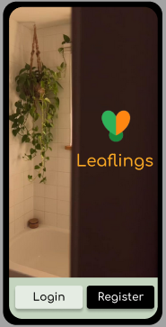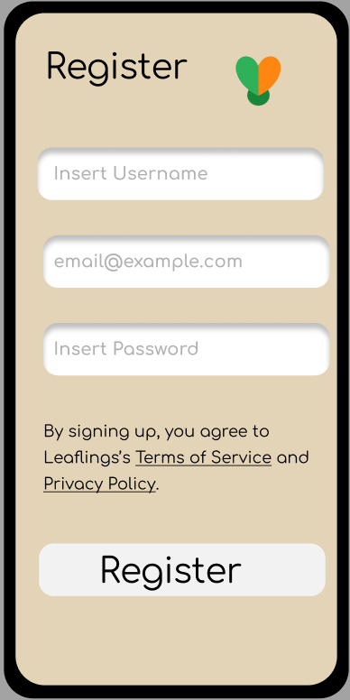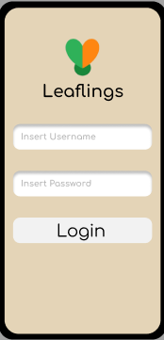

Figure - Login/register screens Register Screen Login Screen

### User Interfaces – Mobile Version – Homepage

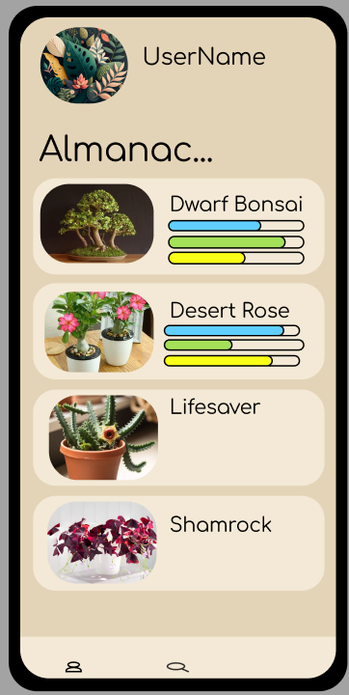

Figure - Homepage Screen

**The leafings homepage serves as the central page for a user to easily navigate through the app’s key features. It was designed to combine both simplicity and the navigation of the app.   
  
Navigation**: At the top of the screen, users have clickables to **access to their profile and plant collection**, keeping personalized content readily available.

**Almanac Section**: The almanac provides an overview of the plants in the database, displaying each plant's name alongside visual clues that indicate important metrics such as water levels, sunlight exposure, and experience necessary. This layout allows users to discover new plants every time they enter the app, while keeping the access to personalized content easily accessible. The almanac is supposed to represent an endless scrollable, which will load more and more plant entries the more a user scrolls.

**Plant Cards:** Each Plant is represented inside a “card”. Each card is composed of a clear image, picked by admins of the platform, a name, and the bars that indicate the plant’s needs in a quick fashion.

### User Interfaces – Mobile Version – User Homepage

The User Homepage is what a user can access my clicking the profile option.   
In the profile screen, the user is presented with a section dedicated to the user’s preferences (where a user may change their preferences which include, the sun exposure they get for their plants, the amount of time they have to care for plants and the experience they have). They are also presented with a scrollable element where the user’s plants will be presented in “card” elements aswell when a user click, they’ll be presented with a new screen, with the information for their plant, an editable text wall representing a plant diary, and a button that allows a user to remove the plant from their personal plants.

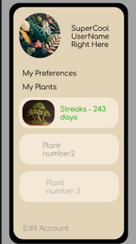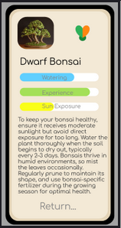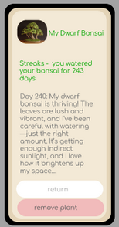

Figure - User Homepage Screens Check Plant Screen My Plant Diary

### User Interfaces – Mobile Version – Edit Account Screens

The following screens are accessible by both the “Edit Account” button in the User Homepage and the “My preferences” clickable in the same page.  
  
Edit Account allows a user to change their email and password while the “My Preferences” screen allows a user to change their availability settings.

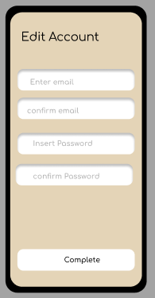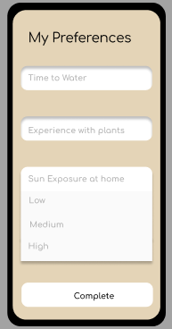

Figure - Edit Account and Preferences Screen

### User Interfaces – Web Browser – First Screens (Login and Register)

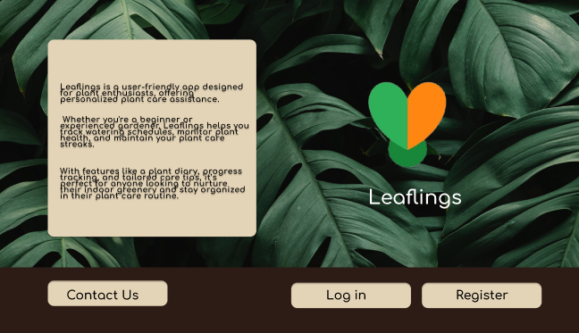

Figure - Browser LandingPage

1. LandingPage: This screen presents the entry point of a user into the browser version of our app.

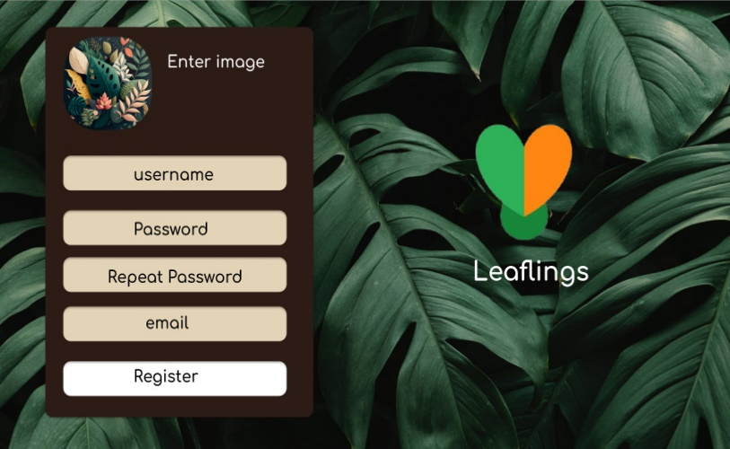

1. Register: This screen presents the

The form a user has to fill with their

Their information before being allowed to access the platform.

Figure - Register Screen

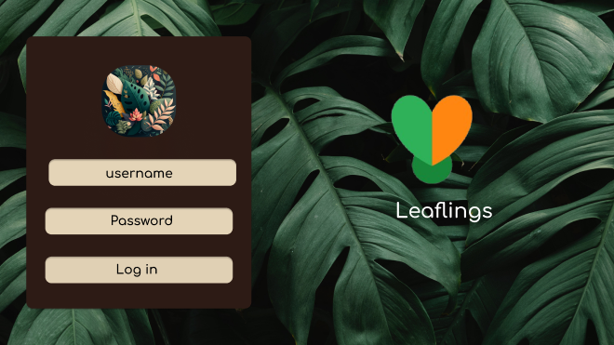

Figure - Login Screen

1. Login: This screen presents the user who has already registered with the platform the form they must fill before entering their account.

### User Interfaces – Web Browser – Homepage

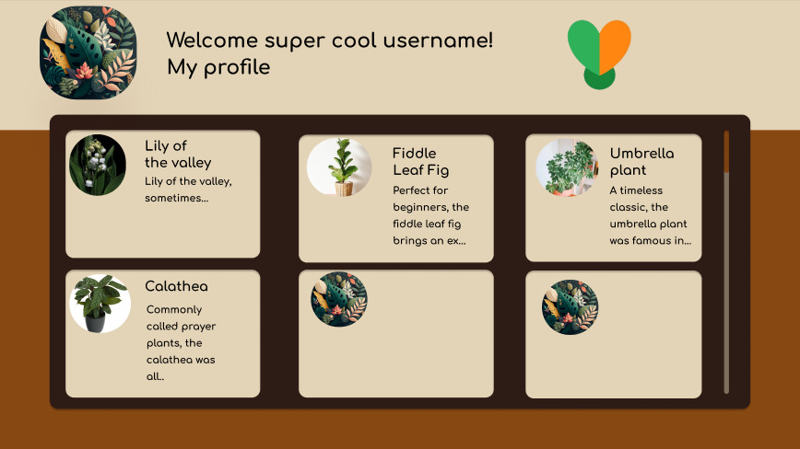

Figure - Homepage

The homepage is designed to be simplistic, and allow the user to be presented with everything without much strain on the eye. The Plant Manual is untitled as it fills most of the screen, it is also designed to be implemented as an infinite scrollable. The clickable element “My Plants” will guide the user to his personal page. The plants are still represented by “cards”, which, when clicked will present a detailed pop up with all the information of a plant.

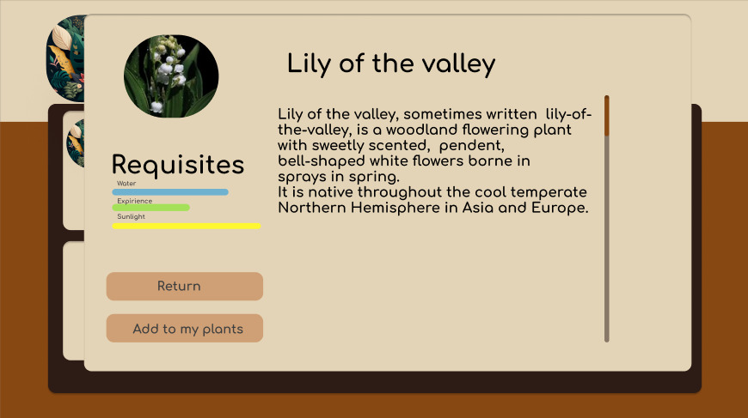

Figure - Card presentation

### User Interfaces – Web Browser – User Homepage

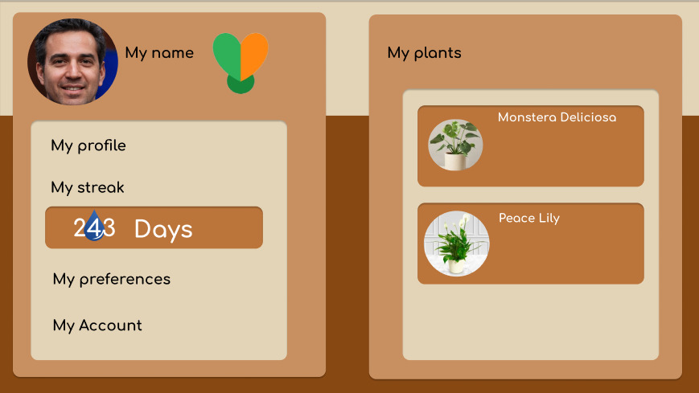

Figure - profile homepage

The user homepage is where a user arrives once they choose the option “My Profile” in the app homepage. It holds their streak (number of days logged into the app count as having watered your plants), and it also holds a second screen card which will change depending on the option chosen by the user. If they select “My Preferences” then the my preferences screen will show up, but if they click their name again, their plants will be displayed again. To go back to the app homepage, they should click the leaflings logo.

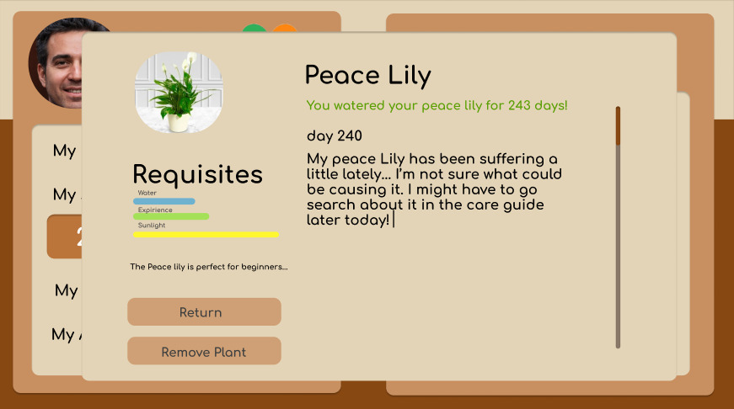

Figure - check a user owned plant

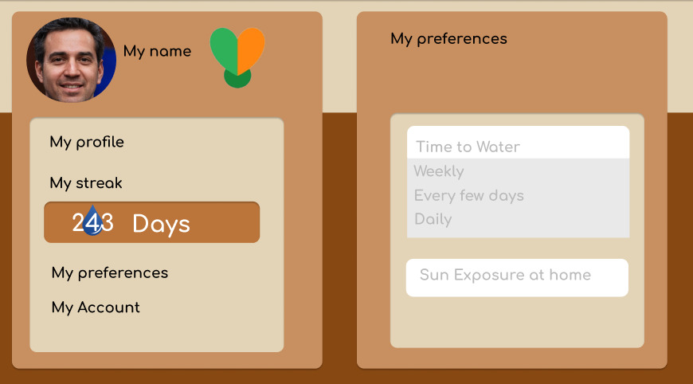

Figure - Change Preferences Page

## Use Case Scenarios

### User Management

* + 1. **Register User**

|  |  |
| --- | --- |
| Name | Register User |
| Actors | User |
| Pre-Conditions | Users must have access to the platform. |
| Typical-Flow | A new user will access the platform and choose the **Register** option, upon which they will be prompted to complete a form with the basic information needed to create an account. After completing the form, the user may then select the **Submit** button, effectively creating their account. |
| Alternative-Flow | **Improper form data:**  In case the user fails to properly fill out the form, they will not be able to submit their information, until the form is correctly filled out.  **Redundancy:** If a user’s unique identifier (email) coincides with one already present in the database, the user will be notified, and will not be able to create an account. |
| Extensions | **N/A** |
| Post-Conditions | The user will now have access to all of the app’s functionalities, and will be able to log in with the credentials they have chosen. |

Table - Register User Use Case

* + - 1. **Functional Requirements**

|  |  |
| --- | --- |
| **Category** | **User Management** |
| **ID** | FRUM-01 |
| **Name** | Login and Registration |
| **Description** | Users must be able to register in the application, upon which their data will be securely kept in the database. If a user is registered, they will then be able to log into their account, allowing them to use the platform. |
| **Priority** | 1 - Essential |
| **State** | Proposed |
| **Restrictions** | N/A |

Table - Func Requirement Login And Register

* + 1. **Login**

|  |  |
| --- | --- |
| Name | Login |
| Actors | User, Admin |
| Pre-Conditions | Users must be registered. |
| Typical-Flow | A registered user will arrive at the entry screen, and, if they aren’t logged in, they can then enter their credentials, upon which they will be granted access to their respective dashboard. |
| Alternative-Flow | **Improper form data:**  In case the user fails to properly fill out the form, they will not be able to submit their information, until the form is correctly filled out. |
| Extensions | **N/A** |
| Post-Conditions | The user will now have access to all of the app’s functionalities, and will be able to log in with the credentials they have chosen. |

Table - Use Case Scenario Login

* + - 1. **Functional Requirements**

|  |  |
| --- | --- |
| **Category** | **User Management** |
| **ID** | FRUM-01 |
| **Name** | Login and Registration |
| **Description** | Users must be able to register in the application, upon which their data will be securely kept in the database. If a user is registered, they will then be able to log into their account, allowing them to use the platform. |
| **Priority** | 1 - Essential |
| **State** | Proposed |
| **Restrictions** | N/A |

Table - Func Requirement Login and Register

* + 1. **Create User Profile**

|  |  |
| --- | --- |
| Name | Create User Profile |
| Actors | User |
| Pre-Conditions | Users must have access to the platform, and must be registered |
| Typical-Flow | Once a user is registered, they will be able to complete their profile with their caretaking information, which is to say, describe their environment and conditions (by filling out a multiple-choice form). To do this, a user will access their profile, **Edit Profile**, and fill out all of the relevant fields. Once complete, the user will select **Submit** in order to persist their data. |
| Alternative-Flow | **Improper form data:**  In case the user fails to properly fill out the form, they will not be able to submit their information, until the form is correctly filled out. |
| Extensions | A user will be able to change and update their profile at any given time. |
| Post-Conditions | The user will now have access to a customized feed of suitable plants for their environment. |

Table - Use Case Scenario Create User Profile

* + - 1. **Functional Requirements**

|  |  |
| --- | --- |
| **Category** | **User Management** |
| **ID** | FRUM-02 |
| **Name** | Profile Creation |
| **Description** | Registered users should be able to create a profile detailing the available environment for plant care (caretaker profile). |
| **Priority** | 1 - Essential |
| **State** | Proposed |
| **Restrictions** | Only registered users should have access to this functionality |

Table - Func Requirement Profile Creation

* + 1. **Alter User Profile**

|  |  |
| --- | --- |
| Name | Alter User Profile |
| Actors | User |
| Pre-Conditions | Users must have access to the platform, and must be registered |
| Typical-Flow | Once a user has a profile created, they can then access it, selecting the **Edit** option, and updating any information they deem necessary. |
| Alternative-Flow | **Improper form data:**  In case the user fails to properly fill out the form, they will not be able to submit their information, until the form is correctly filled out. |
| Extensions | **N/A** |
| Post-Conditions | The user will now have access to a customized feed of suitable plants for their environment. |

Table - Use Case Scenario Alter User Profile

* + - 1. **Functional Requirements**

|  |  |
| --- | --- |
| **Category** | **User Management** |
| **ID** | FRUM-02.1 |
| **Name** | Profile Alteration |
| **Description** | A user with an existing profile should be able to change it at any time, updating their information, as well as their caretaker profile |
| **Priority** | 1 - Essential |
| **State** | Proposed |
| **Restrictions** | Only registered users with an existing profile should have access to this functionality. |

Table - Func Requirement Profile Alteration

### Plant Database and Matchmaking

* + 1. **Access Plant Directory**

|  |  |
| --- | --- |
| Name | Access Plant Directory |
| Actors | User, Admin |
| Pre-Conditions | Users must have access to the platform, and must be registered, and the system and database must be available. |
| Typical-Flow | User selects the **Almanac** section of the application. |
| Alternative-Flow | **N/A** |
| Extensions | Once in the **Almanac** page, a user can use the search bar to look for specific plants.  A user can also access a specific plant, and explore the **Plant Care Guide** or simply read the plant’s description |
| Post-Conditions | The user will now have access to a feed of all the plants available in the database, along with their information. |

Table - Use Case Scenario Access Plant Directory

* + - 1. **Functional Requirements**

|  |  |
| --- | --- |
| **Category** | **Plant Database and Matchmaking** |
| **ID** | FRP-01 |
| **Name** | Plant Directory Access |
| **Description** | Users should be able to browse the entirety of the plant catalog, accessing information about each entry. |
| **Priority** | 1 - Essential |
| **State** | Proposed |
| **Restrictions** | Only registered users should have access to this functionality |

Table - Func Requirement Plant Directory Access

|  |  |
| --- | --- |
| **Category** | **Plant Database and Matchmaking** |
| **ID** | FRP-01.1 |
| **Name** | Plant Information Display |
| **Description** | Upon selection of a plant present in the catalog, a user should be able to inspect its characteristics. |
| **Priority** | 1 - Essential |
| **State** | Proposed |
| **Restrictions** | Only registered users should have access to this functionality |

Table - Func Requirement Plant Info Display

|  |  |
| --- | --- |
| **Category** | **Plant Database and Matchmaking** |
| **ID** | FRP-01.2 |
| **Name** | Caretaking Guide |
| **Description** | Associated with each plant, besides their general information and characteristics, there must be a caretaking guide, detailing the steps and precautions to take when caring for this plant. |
| **Priority** | 1 - Essential |
| **State** | Proposed |
| **Restrictions** | Only registered users should have access to this functionality, the user’s caretaker profile must be completed, and there must be plants in the database capable of thriving according to user’s profile. |

Table - Func Requirement Plant Info Display

|  |  |
| --- | --- |
| **Category** | **Plant Database and Matchmaking** |
| **ID** | FRP-01.3 |
| **Name** | Searching and Filtering |
| **Description** | Users should be able to look for plants within the database, applying filters in regards to the type of plant. |
| **Priority** | 2 - High Priority |
| **State** | Proposed |
| **Restrictions** | Only registered users should have access to this functionality |

Table - Func Requirement Searching And Filtering

* + 1. **Matching Plants to Users**

|  |  |
| --- | --- |
| Name | Matching Plants to Users |
| Actors | User |
| Pre-Conditions | Users must have access to the platform, and must be registered, their profile must be complete, and the system and database must be available. |
| Typical-Flow | User accesses the **Almanac** and selects the **For Me** option.  The system will compare the user’s available environment and the plant’s needs, and create a feed containing the plants suitable for the user. |
| Alternative-Flow | **No suitable plants:** If for some reason the user’s profile does not match with any plants in any capacity, the filter will return no results. |
| Extensions | Much like in the **Almanac** page, a user can use the search bar to look for specific plants.  A user can also access a specific plant, and explore the **Plant Care Guide** or simply read the plant’s description |
| Post-Conditions | The user will now have access to a customized feed of suitable plants for their environment. |

Table - Use Case Scenario Match Plants To Users

* + - 1. **Functional Requirements**

|  |  |
| --- | --- |
| **ID** | FRP-02 |
| **Name** | Plant Matchmaking |
| **Description** | Through the use of a matchmaking algorithm, and taking into account the user profile and plant characteristics, the program should be able to provide a personalized catalog containing only plants which abide by the user’s caretaker profile specifications. |
| **Priority** | 1 - Essential |
| **State** | Proposed |
| **Restrictions** | Only registered users should have access to this functionality, the user’s caretaker profile must be completed, and there must be plants in the database capable of thriving according to the user's profile. |

Table - Func Requirement Plant Matchmaking

* + 1. **Adding Plants to User Favorites**

|  |  |
| --- | --- |
| Name | Adding Plants to User Favorites |
| Actors | User |
| Pre-Conditions | Users must have access to the platform, and must be registered, their profile must be complete, and the system and database must be available. |
| Typical-Flow | A user accesses a specific plant’s page through the **Almanac**. Then, within the plant page, a user can select the **Add** option, which will add a plant to the user’s favorites (**Garden**), making it easily accessible to check any information. |
| Alternative-Flow | **N/A** |
| Extensions | **N/A** |
| Post-Conditions | The plant is added to the user’s collection, for easier access, and will allow the user to enable reminders to care for it, if they effectively own this plant. |

Table - Use Case Scenario Adding Plants to Users Favorites

* + - 1. **Functional Requirements**

|  |  |
| --- | --- |
| **Category** | **Plant Database and Matchmaking** |
| **ID** | FRP-03 |
| **Name** | Add Plant to Garden |
| **Description** | If the user decides to effectively care for one of the plants present in the catalog, they can then add it to their **Garden**, which will be a separate collection of plants selected by the user. Here, their information will be readily available. |
| **Priority** | 1 - Essential |
| **State** | Proposed |
| **Restrictions** | Only registered users should have access to this functionality, and the user must have selected at least one plant to care for, in order for the Garden to be available. |

Table - Func Requirement Add Plant To Garden

### Administration

* + 1. **Remove User**

|  |  |
| --- | --- |
| Name | Remove User |
| Actors | Admin |
| Pre-Conditions | User must have administrative permission and be authenticated |
| Typical-Flow | An admin will access the **User Directory**, and select the user they wish to remove. They will then be prompted with a confirmation message, and upon answering affirmatively, the user’s account will be **Deactivated**. |
| Alternative-Flow | **Negative confirmation:**  In case the admin does not confirm the deletion, the action will not be performed. |
| Extensions | **N/A** |
| Post-Conditions | The user’s account will no longer be available. |

Table - Use Case Scenario Remove User

* + - 1. **Functional Requirements**

|  |  |
| --- | --- |
| **Category** | **Administration** |
| **ID** | FRA-01 |
| **Name** | User Deletion |
| **Description** | The platform admins will be able to remove user accounts from the platform |
| **Priority** | 5 - Essential |
| **State** | Proposed |
| **Restrictions** | Only authorized admins have access to this functionality |

Table - Func Requirement Remove User

* + 1. **Access User Information**

|  |  |
| --- | --- |
| Name | Access User Information |
| Actors | Admin |
| Pre-Conditions | User must have administrative permission and be authenticated |
| Typical-Flow | An admin will access the **User Directory**, upon which they will be able to navigate the list of registered users. |
| Alternative-Flow | **N/A** |
| Extensions | An admin will be able to view a specific user’s information. |
| Post-Conditions | **N/A** |

Table - Use Case Scenario Access User Information

* + - 1. **Functional Requirements**

|  |  |
| --- | --- |
| **Category** | **Administration** |
| **ID** | FRA-02 |
| **Name** | User Information Access |
| **Description** | The platform admins will have access to user information, except passwords |
| **Priority** | 5 - Essential |
| **State** | Proposed |
| **Restrictions** | Only authorized admins have access to this functionality |

Table - Func Requirement User Information Access

* + 1. **Plant Creation**

|  |  |
| --- | --- |
| Name | Plant Creation |
| Actors | Admin |
| Pre-Conditions | User must have administrative permission and be authenticated |
| Typical-Flow | An admin will access the **Plant Directory**, and select the **Add new Plant** option. They will then be prompted to fill out a form detailing the plant information. Once the form is completed, they will be able to **Submit** the new plant, upon which it will be persisted in the database. |
| Alternative-Flow | **Improper form data:**  In case the user fails to properly fill out the form, they will not be able to submit the plant, until the form is correctly filled out.  **Redundancy:** If a plant’s unique identifier (scientific name) coincides with one already present in the database, the user will be notified, and will not be able to proceed with the addition. |
| Extensions | **N/A** |
| Post-Conditions | The plant will be available in the directory and ready for operations. |

Table - Use Case Scenario Plant Creation

* + - 1. **Functional Requirements**

|  |  |
| --- | --- |
| **Category** | **Administration** |
| **ID** | FRA-03 |
| **Name** | Plant Creation |
| **Description** | The platform admins will be able to add plants to the database, without directly accessing it |
| **Priority** | 5 - Essential |
| **State** | Proposed |
| **Restrictions** | Only authorized admins have access to this functionality |

Table - Func Requirement Plant Creation

* + 1. **Edit Plant Information**

|  |  |
| --- | --- |
| Name | Edit Plant Information |
| Actors | Admin |
| Pre-Conditions | User must have administrative permission and be authenticated |
| Typical-Flow | An admin will access the **Plant Directory**, and select the plant they wish to edit, and edit the fields as they see fit. After this is done, they can **Submit** the update. |
| Alternative-Flow | **Improper form data:**  In case the user fails to properly fill out the form, they will not be able to submit the plant, until the form is correctly filled out.  **Redundancy:** If a plant’s unique identifier (scientific name) coincides with one already present in the database, the user will be notified, and will not be able to proceed with the edition. |
| Extensions | **N/A** |
| Post-Conditions | The plant’s information is now updated and will be used in the platform. |

Table - Use Case Scenario Edit Plant Information

* + - 1. **Functional Requirements**

|  |  |
| --- | --- |
| **Category** | **Administration** |
| **ID** | FRA-04 |
| **Name** | Plant Edition |
| **Description** | The platform admins will be able to edit/update plant information |
| **Priority** | 5 - Essential |
| **State** | Proposed |
| **Restrictions** | Only authorized admins have access to this functionality |

Table - Func Requirement Plant Edition

### Other Functional Requirements

* + 1. **Engagement**

|  |  |
| --- | --- |
| **Category** | **Engagement** |
| **ID** | FRE-01 |
| **Name** | Reminder System |
| **Description** | Given the user’s Garden collection, reminders will be sent out, to remind the user of when they need to water their plant, or simply log the day into the application. |
| **Priority** | 3 - Medium Priority |
| **State** | Proposed |
| **Restrictions** | Only registered users should have access to this functionality, and the user must have selected at least one plant to care for. |

Table – Func Requirement Reminder System

|  |  |
| --- | --- |
| **Category** | **Engagement** |
| **ID** | FRE-02 |
| **Name** | Streak System |
| **Description** | With continuous logging of caretaking into the application, the system will award the user by recording the consecutive entries, incentivizing consistency and responsibility. |
| **Priority** | 3 - Medium Priority |
| **State** | Proposed |
| **Restrictions** | Only registered users should have access to this functionality, and the user must have selected at least one plant to care for. |

Table - Func Requirement Streaks

### Product Backlog

**LOGIN AND REGISTRY**

User story 1 - AS A DEVELOPER I want the API to effectively save information regarding users (new and old) in the database FOR usage in the system.

User story 2 - AS A USER I want to be able to register and maintain said register in the app SO I CAN use across a long period of time with my personalized history.

User story 3 - AS AN ADMIN I want to be able to authenticate myself IN ORDER TO have access to admin privileges to the platform.

**Create Profile**

User story 4 - AS A USER I want to be able to create my profile with the info necessary IN ORDER TO find my ideal plant matches;

**Edit Profile**

User story 5 - AS A USER I want to be able to edit my profile SO I CAN update the info regarding my life conditions and receive better plant suggestions;

User story 6 - AS AN ADMIN I want to be able to remove users TO avoid scenarios like multiple accounts and offensive user names.

**ACCESS PLANT DIRECTORY (MANUAL)**

User story 7 - AS A USER I want to be able to access the plant manual SO I CAN discover new plants, and check information I find important;

User story 8 - AS A DEV I want to create the plant manual in a visually appealing manner for both the mobile and web browser apps IN ORDER TO make the final product more attractive to the user;

User story 9 - AS AN ADMIN I want to be able to access the plant manual SO I CAN verify information and verify that the information changes I implemented were correctly applied;

**INFORMATION DISPLAY**

User story 10 – AS AN ADMIN I want to be able to create ads IN ORDER to post them to the platform.

User story 11 - AS A DEV I want to create the plant manual in a manner that it isn't visually overwhelming to the user, for that end I should have an initial display that serves as a plant presentation card, and only when said card is selected should the rest of the information be displayed. I want this IN ORDER TO avoid overwhelming a user visually.

User story 12 - AS AN ADMIN I want the system to force me to fully complete the form to add new plants to the platform IN ORDER TO avoid half registries in the final product plant manual;

**PLANT CARETAKING GUIDE**

User story 13 - AS A USER I want to be able to access care guides SO I CAN better take care of the plants I've selected as my own;

User story 14 - AS AN ADMIN I want the information for the guides to be easy and intuitive to access SO I CAN better serve the user;

User story 15 - AS AN ADMIN I want to be able to edit the info relative to plants and their guides so I can keep the information in the platform up-to-date;

**SEARCH AND FILTER**

User story 16 - AS A USER I want to be able to search specific names in the manual SO I CAN be quicker with my searches.

User story 17 - AS AN USER I want to be able to search specific names in the manual SO I CAN quicker with my searches.

User story 18 - AS A USER I want to be able to filter my plant matches SO I CAN better find plants that I both like, and fit my home environment.

**PLANT MATCHMAKING**

User story 19 - AS A USER I want to find plants that match my profile's preferences SO I CAN keep them in my house with the help of the guides provided by the app

User story 20 - AS A DEV I want to implement an algorithm that'll match plants to user profile preferences IN ORDER TO provide the main attraction feature of the app

User story 21 - AS A DEV I want to be able to provide the user with the option for a paid subscription SO THAT I CAN make a bigger profit.

User story 22 – AS A USER I want to be able to receive warnings on days where weather might be dangerous to any plants I may have outside.

**PLANT GARDEN (My Plants section)**

User story 23 - AS A USER I want to be able to save the plants that I find relevant to me, IN ORDER TO have their information available to me at moment's notice.

User story 24 - AS A USER I want to be able to write in my plant diary SO THAT I CAN keep track of the progress I’ve been making with my plant.

User story 25 - AS A USER I want to have access to multiple plants in my garden SO THAT I can keep multiple plants at home.

## Other Nonfunctional Requirements

### Security Requirements

|  |  |
| --- | --- |
| **Category** | **Safety and Security** |
| **ID** | NFRS - 01 |
| **Name** | Password Encryption |
| **Description** | The user’s password will never be directly kept in the database, without first being encrypted, for security reasons, ensuring a robust layer of protection. |
| **Priority** | 1 - Essential |
| **State** | Closed |
| **Restrictions** | N/A |

Table - Non Func Requirement Password Encryption

|  |  |
| --- | --- |
| **Category** | **Safety and Security** |
| **ID** | NFRS - 02 |
| **Name** | Token Authentication |
| **Description** | The authentication will be done with the use of access tokens, providing security and efficiency, with server side keys. |
| **Priority** | 1 - Essential |
| **State** | Closed |
| **Restrictions** | N/A |

Table - Non Func Requirement Token Authentication

### Software Quality Attributes

|  |  |
| --- | --- |
| **Category** | **Accessibility** |
| **ID** | NFRA - 01 |
| **Name** | Ease of Use |
| **Description** | It is crucial that the system is developed in such a way that users will find it intuitive and easy to navigate. As such, the development team will use the www.acessibilidade.gov.pt website in order to gauge the level of accessibility as the application gets developed, to ensure the best possible experience. |
| **Priority** | 2 - High Priority |
| **State** | Closed |
| **Restrictions** | N/A |

Table - Non Func Requirement Ease of Use

## Diagrams

### Package Diagram

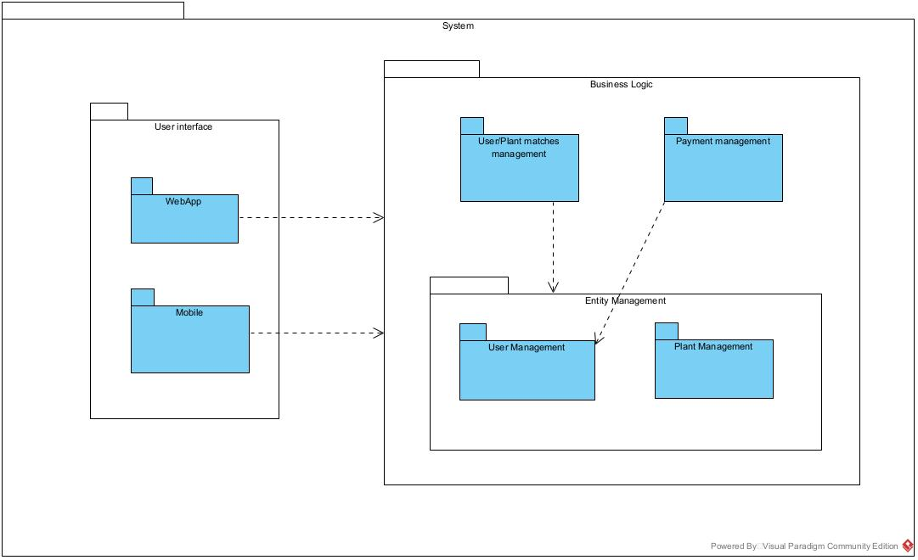

Figure - Package Diagram

**Mobile and Webapp** – Responsible for handling the user interface, presenting the system’s functionality to the user.

**User Management** - responsible for handling user-related tasks, such as authentication, profile editing, and permission handling.

**Plant Management** – responsible for handling plant related tasks.

**UserPlant Matches** – dependent on both user and plant management, it’s a package that bridges the information shared by the two packages.

### Sequence Diagrams

**Register User**

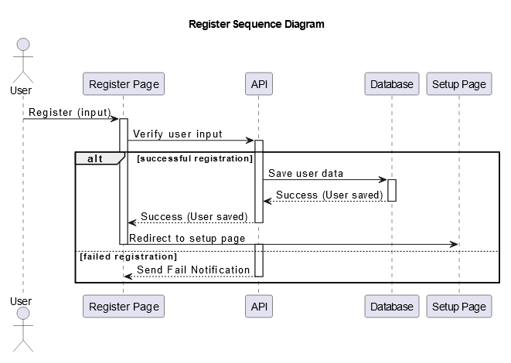

Figure - Register Sequence Diagram

When registering, a user will introduce fill out a register form in the platform, which will then send said form to the API for verification. If the information is verified correctly, the API will save the information into the database, and the user will receive a notice saying that they were registered and redirected to the setup page.   
If the user input is not validated, the API will send a failure notification and the user will receive a notice that they must correct the inputs in the platform.

**User Fill Profile**

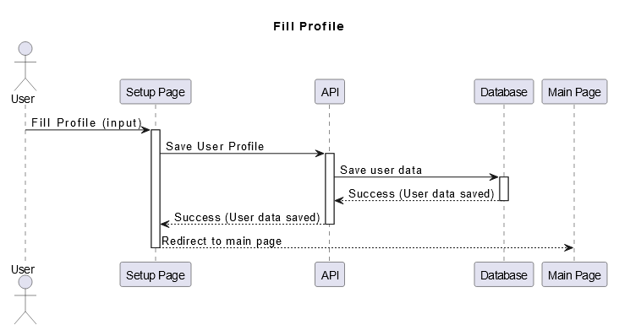

Figure - Fill Profile Sequence Diagram

When filling a profile, a user will have the possibility to fill their needs through optional values regarding light availability at home, time they have to dedicate etc. Once they’ve filled the form, the API will save the information of the user into the database, and the end user will be redirected to the main page.

**User Edit Profile**

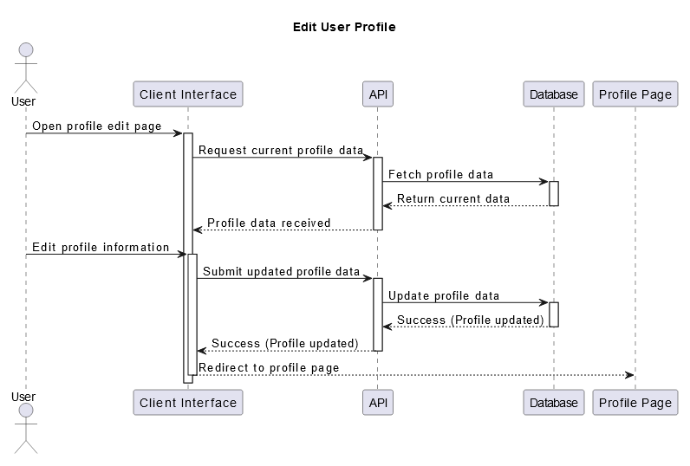

Figure - Edit User Profile Sequence Diagram

For a user to edit their information, they must access the pages dedicated to the functionality, the API will then fetch their current profile data and present it in fields for the user so that they can then change the inputs in the different fields; Once done, the user will request the platform to save the new information, and the API will save it into the information, and then redirect the end user to their profile page.

**Get Matching Plants**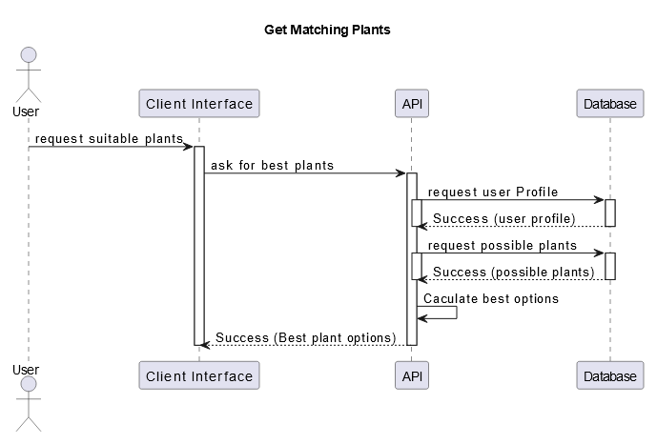

Figure - Get Matching Plant Sequence Diagram

For a User to get their matching plants, a request will be done to the API, which will then fetch the User qualitative information, and the qualitative information of the plants. It will then run an algorithm that matches both users and plants, and will then present the result matches to the end user.

**Add New Plant**

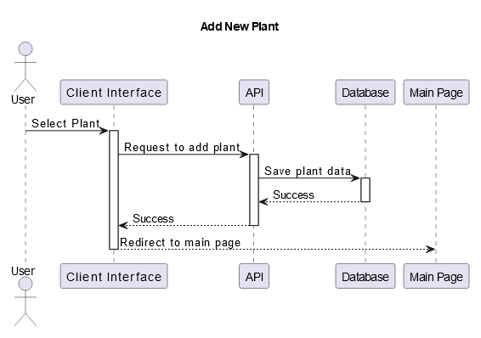

Figure - Add New Plant Sequence Diagram

When adding a new plant, the end user will select a plant they wish to have associated to them, make a request to associate them to their profiles, and the Api will then save the new UserPlant data, and redirect the user to the main page.

**Remove Plant**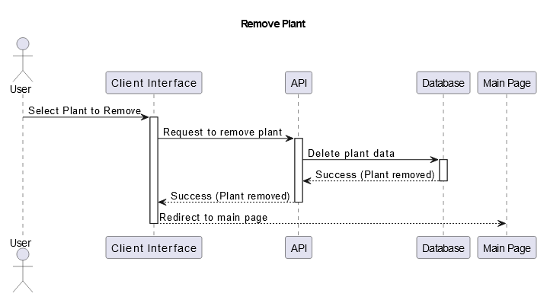

Figure - Remove Plant Sequence Diagram

When a user wishes to remove a plant from their profile, they make a request on the selected plant, and the API will then delete the entry of the UserPlant from the database, and free the space for the end user to be able to select another plant in the future.

**View User Plants**

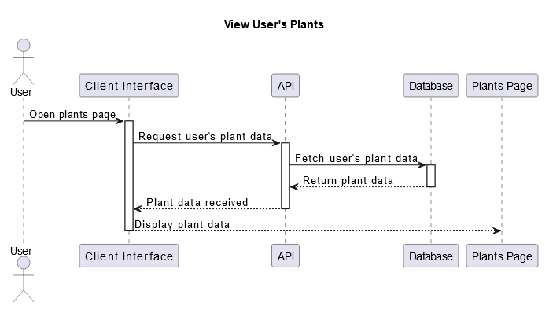

Figure - View User's Plants Sequence Diagram

When a user wishes to consult one of their plants, they must open their plant page, and the API will fetch the data of that Users plants and return it.

### Class Diagram

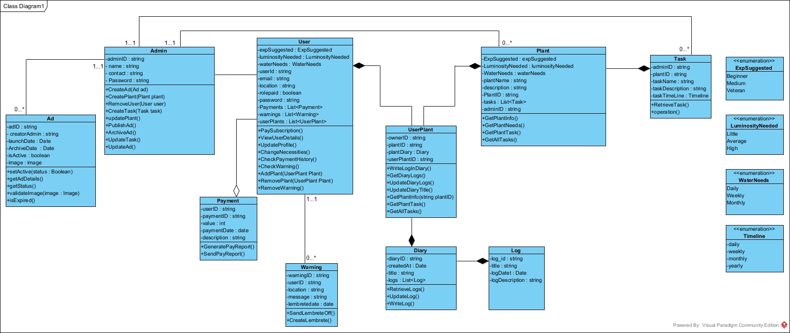

Figure - Class Diagram

### Architecture Diagram

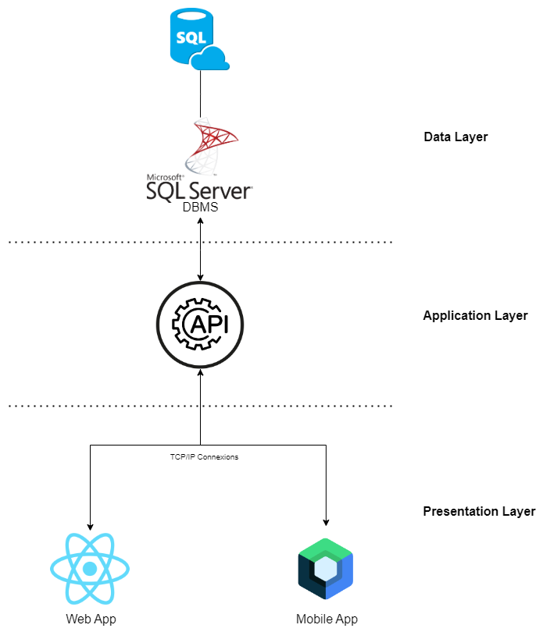

Figure - Architecture Diagram

## Database Design and Normalization

The database supports the entirety of the system through maintaining all the information and relationships between the information necessary for the system’s functionality. The database was designed for this end, and MicrosoftSQL server was chosen as the database management platform.

### ER Diagram

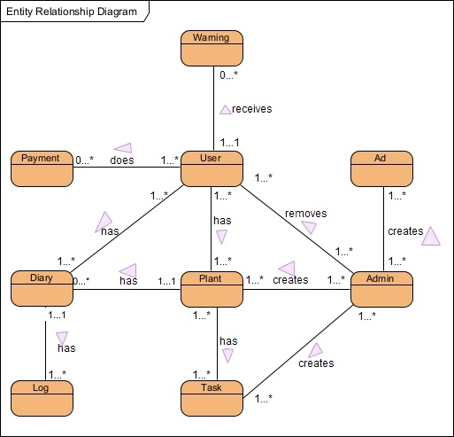

Figure - First ER Diagram

This first ER diagram is supposed to represent an initial, high-level view of the database entities and the relationships that exist between said entities. In the following page we identify each entity, when they occur and their relationships.

### Identify Entities and relationships

|  |  |  |  |
| --- | --- | --- | --- |
| **Entity** | **Description** | **Aliases** | **Occurrences** |
| **User** | Represents an end user that uses the platform | Client, platform member. | A user occurs every time an end user signs up for the platform |
| **Admin** | Represents a staff member that is responsible for managing certain processes within the platform. | Staff,  Employee | The platform has a pre-determined number of admins |
| **Plant** | Represents a plant registry (all the information regarding a plant) that is available in the platform | N/A | An admin can create one or multiple plants and add them to the platform |
| **Task** | Represents a unique task that belongs to a plant. | To do’s | A plant can have one or more tasks, they are also admin created. |
| **Diary** | Represents a collective of log entries, dedicated to the end user, so they can keep track of the progress of their plant’s growth, or for other ends. | Journal, record | A diary occurs whenever a User picks a plant to add to their garden. |
| **Log** | Represents a single entry in the diary | Entry, register | A log occurs whenever an end user writes a new entry to their diary |
| **Payment** | Represents a payment that users can make to the platform | Transaction | A user can make one or multiple payments to the platform. |
| **Warning** | Warning represents a notification sent to users when weather conditions in a certain location justify it. | Notifications | A user receives warnings when the weather conditions justify warning a user to be careful of their plants conditions |
| **Ad** | Ad represents an ad to be shown to users. | Advertisements | An admin can create and post one or multiple ads. |

Table - Identify Entities and Relationships

#### Multiplicity of relationships

|  |  |  |  |  |
| --- | --- | --- | --- | --- |
| **entity** | **multiplicity** | **Relationship** | **Multiplicity** | **entity** |
| **User** | 1…1  1…1  1…1  1…1  1…1  1…1 | **Receive**  **Receives**  **Does**  **Has**  **Has**  **Does** | 1…*  1…*  1…*  1…*  1…*  1…* | **Ads**  **Warnings**  **Tasks**  **Plants**  **Diaries**  **Payments** |
| **Admin** | 1…1  1…1  1…1  1…1 | **Manages**  **Manages**  **Manages**  **Removes** | 1…*  1…*  1…*  1…* | **Ads**  **Plants**  **Tasks**  **Users** |
| **Plant** | 1…*  1…1 | **Belong to**  **Contains** | 1…*  1…* | **Users**  **Tasks** |
| **Task** | 1…1 | **Belongs to** | 1…1 | **Plant** |
| **Diary** | 1…1  1…1 | **Belong to**  **Belong to** | 1…1  1…1 | **User**  **Plant** |
| **Log** | 1…1 | **Belongs to** | 1…1 | **Diary** |
| **Payment** | 1…1 | **Is associated to** | 1…1 | **User** |
| **Warning** | 1…1 | **Is Sent to** | 1…* | **User** |
| **Ad** | 1…1 | **Is Served to** | 1…* | **User** |

Table - Multiplicity of relationships

### Assign keys to entities

|  |  |
| --- | --- |
| **Entity** | **Key Value** |
| **User** | **userID** |
| **Admin** | **adminID** |
| **Plant** | **plantID** |
| **Task** | **taskID** |
| **Diary** | **diaryID** |
| **Log** | **logID** |
| **Payment** | **paymentID** |
| **Warning** | **warningID** |
| **Ad** | **adID** |

Table 33 - Assign keys to entities

### Solve redundancies

#### 6.5.1 Examine (1:1) relationships After analyzing all the 1 to 1 relationships, the group concluded that they do not cause redundancy of data.

#### 6.5.2 Solve (*: *) relationships

We have one occurrence of a many to many relationship;

To solve the issue between the User and Plant relationship, where a user can hold multiple plants, and multiple plants can belong to multiple users at the same time we decided to create a third table to hold this relationship called UserPlant. The UserPlant table solves this issue by bridging the relationship, maintaining 1 userID and 1 plantID per plant that belongs to a user.

### Conceptual Model

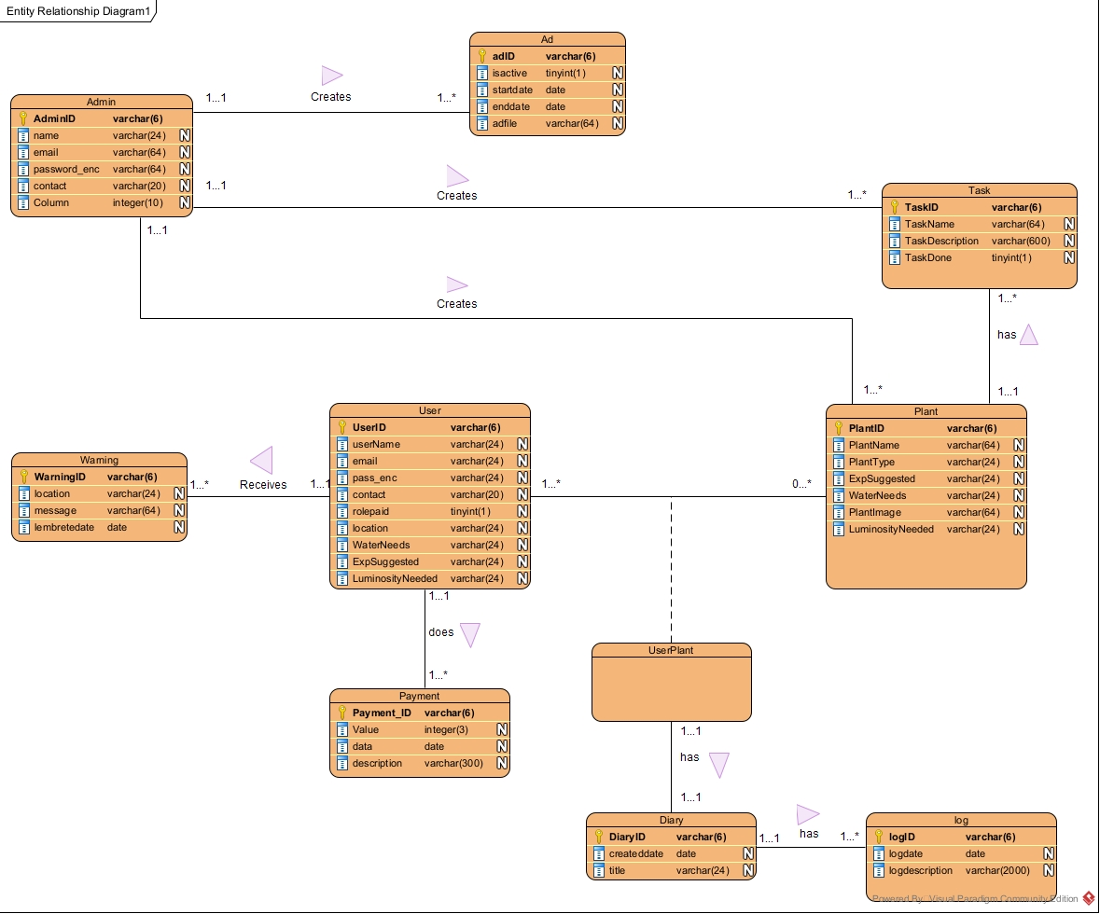

Figure - conceptual model

### Data Dictionary

|  |  |  |  |  |  |  |  |
| --- | --- | --- | --- | --- | --- | --- | --- |
| **Entity** | **Attribute** | **Description** | **Datatype** | **Character Length** | **Acceptable Values** | **Required** | **Null** |
| **Admin** | **AdminID** | Unique Admin identifier | varchar | 6 | N/A | **yes** | **no** |
| **Name** | Admin’s name | varchar | 24 | N/A | **yes** | **no** |
| **Email** | Admin’s contact email | varchar | 64 | N/A | **yes** | **no** |
| **Password** | Encrypted password | varchar | 64 | N/A | **yes** | **no** |
| **Contact** | Admin alternate contact | varchar | 20 | N/A | **yes** | **no** |
| **Ad** | **AdD** | Unique ad identifier | varchar | 6 | N/A | **yes** | **no** |
| **AdminID** | Identifier of the admin that created the ad | varchar | 6 | N/A | **yes** | **no** |
| **IsActive** | Whether or not the ad is active | tinyint | 1 | 1|0 | **yes** | **no** |
| **StartDate** | Starting date for the ad activity | Date | N/A | N/A | **yes** | **no** |
| **EndDate** | Ending date for the ad activity | Date | N/A | N/A | **yes** | **no** |
| **AdFile** | File containing ad information | varchar | 64 | N/A | **yes** | **no** |
| **Task** | **TaskID** | Unique identifier for a task | varchar | 6 | N/A | **yes** | **no** |
| **AdminID** | Admin that created the task | varchar | 6 | N/A | **yes** | **no** |
| **PlantID** | Plant to which the task belongs | varchar | 6 | N/A | **yes** | **no** |
| **TaskName** | Name of the task | varchar | 64 | N/A | **yes** | **no** |
| **TaskDescription** | Description of the task | varchar | 600 | N/A | **yes** | **no** |
| **Plant** | **PlantID** | Unique identifier of the plant | varchar | 6 | N/A | **yes** | **no** |
| **AdminID** | Admin responsible for creating the plant | varchar | 6 | N/A | **yes** | **no** |
| **PlantName** | Name of the plant | varchar | 64 | N/A | **yes** | **no** |
| **PlantType** | Type of plant | varchar | 24 | “Decorative”, “Fruit”, “Vegetable”, “Fungus”,  “Cacti”, “Succulent” | **yes** | **no** |
| **ExpSuggested** | Suggested experience for caretaking | varchar | 24 | “High”, “Intermediate”, “Low” | **yes** | **no** |
| **WaterNeeds** | Plant’s need for water | varchar | 24 | “High”, “Intermediate”, “Low” | **yes** | **no** |
| **LuminosityNeeded** | Plant’s need for light | varchar | 24 | “High”, “Intermediate”, “Low” | **yes** | **no** |
| **PlantImage** | Sample image of the plant | varchar | 64 | N/A | **yes** | **no** |
| **Warning** | **WarningID** | Unique warning identifier | varchar | 6 | N/A | **yes** | **no** |
| **UserID** | Unique identifier of user to receive the warning | varchar | 6 | N/A | **yes** | **no** |
| **Location** | User’s location for the warning | varchar | 24 | List of cities | **yes** | **no** |
| **Message** | Message contained in the warning | varchar | 64 | N/A | **yes** | **no** |
| **LembreteDate** | Date the warning is sent out | date | N/A | N/A | **yes** | **no** |
| **User** | **UserID** | Unique user identifier | varchar | 6 | N/A | **yes** | **no** |
| **Username** | User’s username | varchar | 24 | N/A | **yes** | **no** |
| **Email** | User’s email | varchar | 24 | N/A | **yes** | **no** |
| **Password** | User’s encrypted password | varchar | 24 | N/A | **yes** | **no** |
| **Contact** | User’s contact | varchar | 20 | N/A | **yes** | **no** |
| **Rolepaid** | Whether or not user has paid for premium | tinyint | 1 | 1|0 | **yes** | **no** |
| **Location** | User’s location | varchar | 24 | List of cities | **yes** | **no** |
| **WaterAvailability** | Availability the user has to water their plants | varchar | 24 | “High”, “Intermediate”, “Low” | **yes** | **no** |
| **CareExperience** | User’s experience in plant care | varchar | 24 | “High”, “Intermediate”, “Low” | **yes** | **no** |
| **LuminosityAvailability** | User’s luminosity availability | varchar | 24 | “High”, “Intermediate”, “Low” | **yes** | **no** |
| **UserPlant** | **UserID** | Plant’s owner identifier | varchar | 6 | N/A | **yes** | **no** |
| **PlantID** | Plant identifier | varchar | 6 | N/A | **yes** | **no** |
| **UserPlantID** | Identifies a specific plant belonging to a user | varchar | 6 | N/A | **yes** | **no** |
| **Payment** | **PaymentID** | Unique identifier of the payment | varchar | 6 | N/A | **yes** | **no** |
| **UserID** | Unique identifier of the paying user | varchar | 6 | N/A | **yes** | **no** |
| **Value** | Value present in the payment | integer | 3 | N/A | **yes** | **no** |
| **Date** | Payment date | date | N/A | N/A | **yes** | **no** |
| **Description** | Payment description | varchar | 300 | N/A | **yes** | **no** |
| **Diary** | **DiaryID** | Unique identifier of the diary | varchar | 6 | N/A | **yes** | **no** |
| **UserPlantID** | User’s plant to which the diary belongs | varchar | 6 | N/A | **yes** | **no** |
| **CreatedDate** | Date the diary was created | date | N/A | N/A | **yes** | **no** |
| **Title** | Diary title | varchar | 24 | N/A | **yes** | **no** |
| **Log** | **LogID** | Unique identifier for the log | varchar | 6 | N/A | **yes** | **no** |
| **DiaryID** | Unique identifier for the diary the log belongs to | varchar | 6 | N/A | **yes** | **no** |
| **LogDate** | Date the log was created | date | N/A | N/A | **yes** | **no** |
| **LogDescription** | Content of the log | varchar | 2000 | N/A | **yes** | **no** |

Figure - Data Dictionary

### Logical Model

**Normalization**

The process of normalization is done to validate the relationships obtained in the prior steps. This process is done by working on the dependencies between the attributes on the both ends of a relationship.

**First Normative Form –** in this first level of normalization, each line must correspond to an entry and each column should correspond to only one attribute. By analyzing the previous steps, we conclude that the database is already in this form.

**Second Normative Form –** in this level of normalization, each non key attribute must be completely dependent on the totality of the primary key, and not only to part of the primary key. By analyzing the previous steps, we conclude that the database is in this form.

**Third Normative Form –** in this level of normalization, no non key attribute should be functionally dependent of another attribute that is not primary key. If there are, they should be separated into new tables. After analyzing the previous steps, we conclude that the database is in this form.

Each next step of the normalization presumes that the previous step has been achieved.

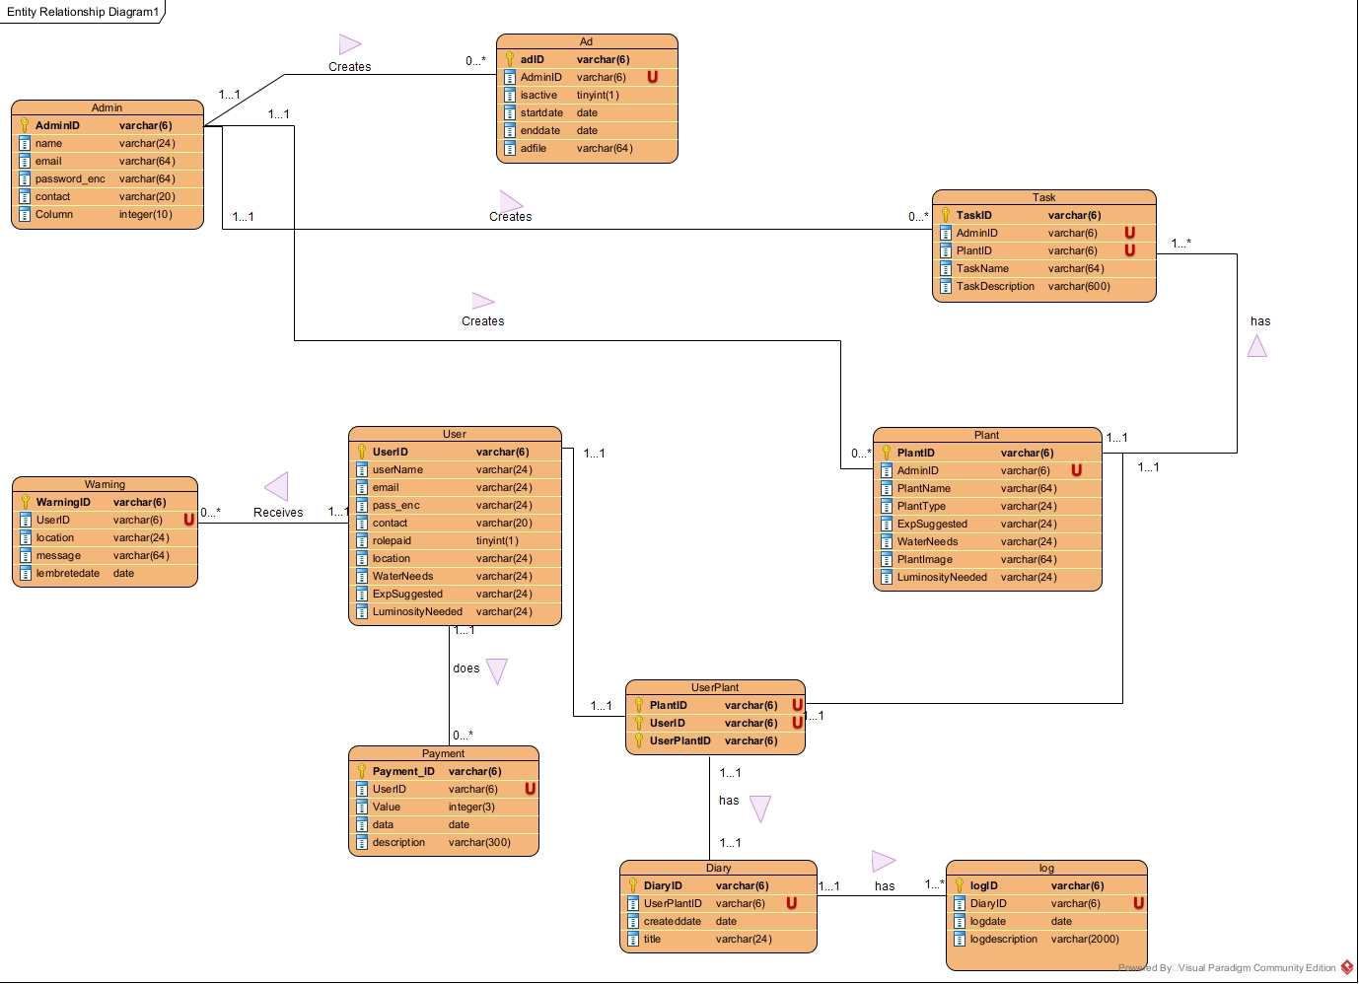**Presentation of the logical diagram**

Figure - Logical Diagram, foreign keys are represented with the letter U

## Use Case

### User Management

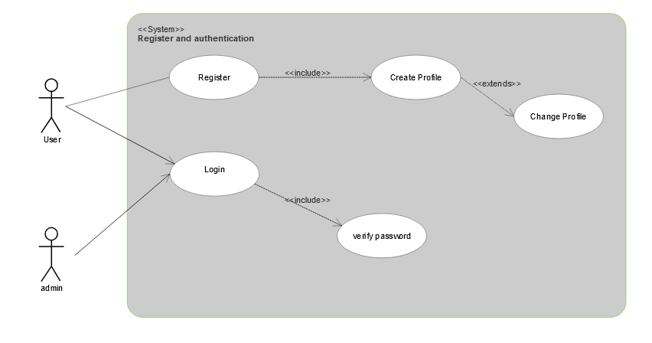

Figure - Use Case Register and authentication

This use case illustrates the register and authentication process for both users, and admins.  
  
**Register**: Only users may register, during the register process, a user will be invited to **create their profile** in order to set them up to use all the functionalities of the system. The user may later **change their profile** if they desire to do so.

**Login**: Both user and admins have access to the login feature. It Includes **verifying password** as part of the authentication process.

### Administration

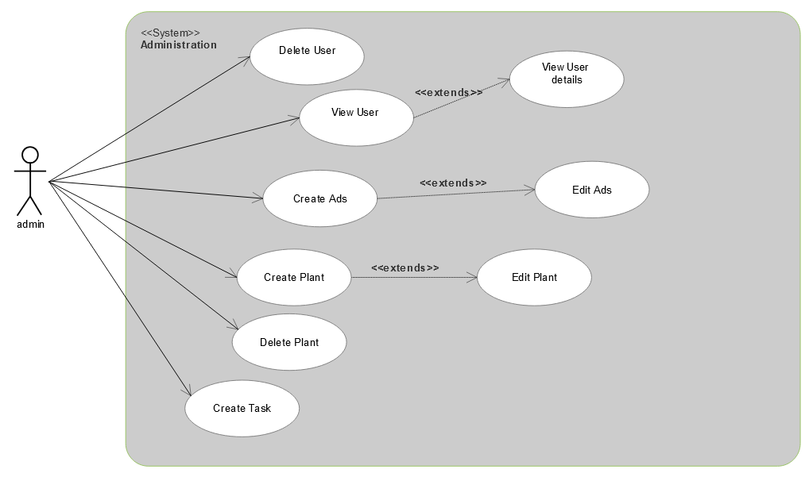

Figure - use case administration

This use case illustrates the administration processes an admin has access to.  
  
**Delete User**: Only admins can delete users, for this, they must select the user they wish to delete.

**View User**: An admin can get the information of a user, like their username for example, this case extends a View User Details, in which more detailed information is given.

**Create plant**: Admins are the type of user capable of creating plant registries. They may later on choose to edit said plant registries.

**Delete plant**: Since admins are able to create plants, they are also able to delete the plant registries from the system.

**Create Task**: Admins are able to create tasks and associate them to plants.

**Create Ad**: Admins are able to create ads, and edit them later on.

### Plant Matchmaking

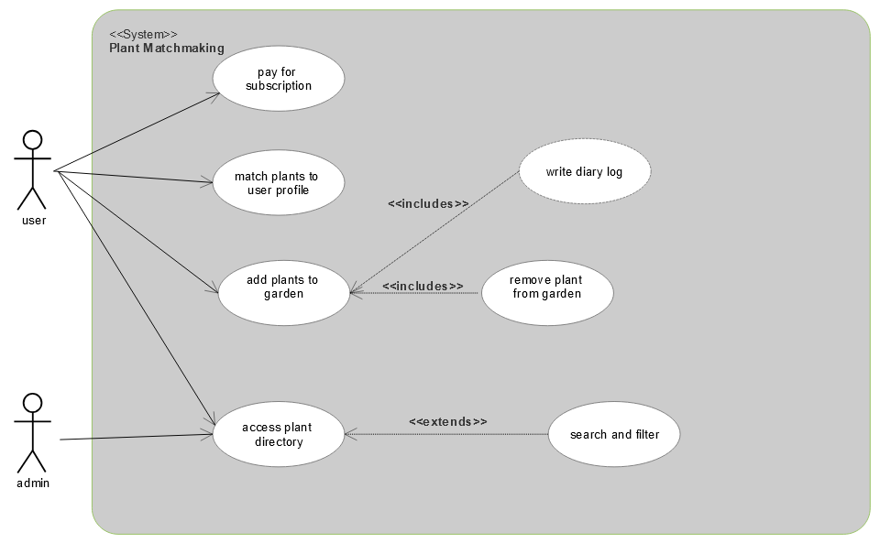

Figure - use case Plant Matchmaking

This case illustrates what both users and admins can do in the front end of the platform.

Pay For subscription: Only users are given the chance to pay for a subscription to the platform.

**Match plants to user profile**: Users can access their plant matches based on their profiles.

**Add plants to garden**: A user may “add a plant to their garden” which is to say, associate a plant registry with their profile, linking both the user and the plant into a user owned plant. They can later **remove** this plant, or **write in their plant diary**.

**Access plant directory**: Both admins can search the plant directory, they are also given the change to search and filter it.